Öko-Recherche
Büro für Umweltforschung und -beratung GmbH

Questionnaire for stakeholders

Assessment of low-GWP alternatives in commercial refrigeration

Instructions
Öko-Recherche and Prof. Michael Kauffeld are entrusted by DG CLIMA of the European Commission under Service Contract No 34.0201/2015/716695/SER/CLIMA.C.2 to gather input from sector experts and stakeholders regarding the availability of low-GWP alternatives in commercial refrigeration. This request is linked to article 21(3) of Regulation (EU) No 517/2014 where the Commission is tasked to assess the 2022 ban on new multipack centralized refrigeration systems for commercial use > 40 kW operating with refrigerants with a GWP of 150 or more, while allowing for a limited use of HFCs in some special types of cascade systems (refrigerants with a GWP of up to 1,500 will still be allowed in primary circuits of cascade systems).
If your company or institution is active in the relevant commercial refrigeration sector and considers itself a relevant stakeholder for this study, you are kindly invited to provide us your input to the questions in this document.
Your responses will be treated as confidential. We nonetheless kindly ask you to provide contact details for any follow-up questions that we might have.
Please feel free to complete this questionnaire on paper or digitally and return it to Öko-Recherche (contact details indicated below). You may also use the extra page to provide further comments or sketches, etc.
Do not hesitate to contact us directly regarding questions, clarifications or if you require help completing the questionnaire.
Contact details
Öko-Recherche GmbH
D-60329 Frankfurt am Main, Germany, Münchener Str. 23
Phone +49 69 252305; Fax +49 69 252306
Email: questionnaire@oekorecherche.de
www.oekorecherche.de
Your contact details:
Name of company/institution
Name of company/institution | ☐ private company ☐ association ☐ NGO ☐ research institute ☐ training or education facility  ☐ other (please specify) ____________
Services provided in commercial refrigeration | ☐ manufacture of equipment  ☐ installation, servicing, repair  ☐ use of equipment (e.g. supermarket)  ☐ consulting  ☐ other (please specify) ____________
Geographic area of your activity | ☐ EU and non-EU  ☐ all EU  ☐ following EU Member State(s) _______________________________________________________  ☐ regional only (please specify)  _______________________________________________________
Contact person
Address
Email
Phone

Questions
- Which do you believe to be the most relevant obligations under Regulation (EU) No 517/2014 (the F-gas Regulation) affecting you and your sector, and why?

- In what way will the HFC phase-down affect your company/institution and your sector?

- What are you doing to prepare for and adjust to the EU HFC phase-down?
Now? | Medium term (until 2020)? | Long term (beyond 2020)?

- What size are the systems you currently manufacture, install/service/repair and/or use in the area of commercial refrigeration, if applicable? Please indicate the category you prioritize in case more than one applies.
Size of systems | Majority of systems
☐ < 40 kW (smaller supermarkets and discounters, convenience stores, gas stations, etc.) | ☐
☐ 40 – 100 kW (medium sized to large supermarkets and discounters) | ☐
☐ > 100 kW (large supermarkets and hypermarkets) | ☐
☐ not applicable

- What types of refrigerants are currently installed (for manufacturer) or used (for end-user) for commercial refrigeration by you? Can you indicate which refrigerants you are installing or using mostly?
Refrigerant | Please indicate the three refrigerants you are installing or using mostly:
☐ R134a | ☐
☐ R290 (propane) | ☐
☐ R404A | ☐
☐ R407A | ☐
☐ R407C | ☐
☐ R407F | ☐
☐ R410A | ☐
☐ R448A (HFC-HFO blend) | ☐
☐ R449A (HFC-HFO blend) | ☐
☐ R507A | ☐
☐ R600a (isobutane) | ☐
☐ R717 (ammonia) | ☐
☐ R744 (CO₂) | ☐
☐ R1234ze(E) (HFO) | ☐
☐ R1234yf (HFO) | ☐
☐ R1270 (propylene) | ☐
☐ other (please specify) ____________ | ☐

- What types of systems do you currently manufacture, install/service/repair and/or use in the commercial sector? Can you estimate the number of systems or provide an indication of the type of systems you predominantly manufacture, install/service/repair and/or use?
Other types of institutions: Please indicate the types of systems most commonly installed in the EU/certain MS at this point in time, to your knowledge.
Types of systems | Estimated number of systems in 2015
Types of systems | Manufactured/installed | Serviced/  repaired
Centralized systems
☐ DX R404A (MT + LT)
☐ DX R134a (MT) + stand-alone (LT)
☐ CO₂ (LT) cascade
☐ Transcritical CO₂
☐ MT + stand-alone LT
☐ MT + LT
☐ Secondary refrigeration circuit with heat transfer fluid
☐ liquid HTF (e.g. glycol) or
☐ evaporating HTF (e.g. CO₂);
☐ CO₂ cascade (LT)
☐ Compact condensing unit with AC function (e.g. Conveni-Pack®)
☐ other ____________________________________
Condensing units
☐ R404A (MT + LT)
☐ R134a (MT) + stand-alone or R404A (LT)
☐ other ___________________________
Stand-alone systems
☐ R134a
☐ R290 (propane)
☐ R404A
☐ R600a (isobutane)
☐ other ___________________________
- Does the prohibition of using HFCs (> 150 GWP) in commercial multipack systems and the systems still allowed from 2022 (see Annex 1) already have an effect on what types of new systems you (or others) manufacture, install/service/repair and/or use?

- What actions are you (or others) taking in preparing for the 2022 ban in the medium term?

- What types of alternative technologies that fulfil the 2022 ban (i.e. systems that are > 40 kW) are currently already available in the commercial sector to your knowledge? Please indicate whether or not your company manufactures or installs these types of systems already, if applicable.
Sample System  (Letters refer to Annex 1) | Description of system | Manufactured, installed, serviced, repaired and/or used by your company?
☐ A | DX < 150 GWP | ☐ Yes ☐ No
☐ B | Cascade CO₂ (primary circuit < 150 GWP) | ☐ Yes ☐ No
☐  C or D | Secondary refrigeration circuit with heat transfer fluid  primary circuit: ☐ R717 ☐ HC ☐ HFO  secondary circuit: ☐ liquid HTF (e.g. glycol) or ☐ evaporating HTF (e.g. CO₂) | ☐ Yes ☐ No
☐  E or F | Combined secondary refrigeration circuit (MT) with heat transfer fluid  primary circuit: ☐ R717 ☐ HC ☐ HFO  secondary circuit: ☐ liquid HTF (e.g. glycol or CO₂)  ☐ evaporating HTF (e.g. CO₂)  and CO₂ cascade (LT; primary circuit < 1,500 GWP) | ☐ Yes ☐ No
☐ G | Transcritical CO₂ (MT, MT+LT) | ☐ Yes ☐ No
☐ other | ____________________________________  (please specify further under Q11 below) | ☐ Yes ☐ No

- What other types of alternative technologies with a refrigeration capacity of ≤ 40 kW are available in the EU to substitute for multipack centralized refrigeration systems of > 40 kW?
☐ Compact condensing unit with AC function (e.g. Conveni-Pack®)
☐ Distributed systems (HFC, R290, HFO-HFC blend, HFO)
☐ Stand-alone systems (HFC, R290, R600a, HFO-HFC blend, HFO)
☐ other ____________________________________(please specify further under Q11 below)

- Please define any additional alternative technologies that you believe would be allowed after 2022 as detailed as possible. You may also draw a sketch of the technologies you have in mind or recommend contact persons for more detailed information. Feel free to make use of the space at the end of the questionnaire.

- Which of the alternative technologies allowed after 2022 available do you consider to be the most cost-effective solution in terms of investment today? How do they compare to conventional HFC systems?
Medium sized to large supermarkets and discounters (40 -100 kW) | Large supermarkets and hypermarkets (> 100 kW)

- Do you anticipate any major developments in terms of investment costs by 2022 for any of the alternative technologies and applications mentioned above? Please specify.
Medium sized to large supermarkets and discounters (40 -100 kW) | Large supermarkets and hypermarkets (> 100 kW)

- Which of the alternative technologies allowed after 2022 indicated above is the most energy efficient during operation? How does each of them compare to conventional state-of-the-art HFC systems? What are the added costs for systems in the same cooling capacity range?
Medium sized to large supermarkets and discounters (40 -100 kW) | Large supermarkets and hypermarkets (> 100 kW)
- Do you anticipate any major developments in terms of energy efficiency by 2022 for any of the alternative technologies and applications mentioned above? Please specify.
Medium sized to large supermarkets and discounters (40 -100 kW) | Large supermarkets and hypermarkets (> 100 kW)

- Which hurdles do you anticipate for a successful and widespread adoption of the alternatives allowed in 2022 in your country/geographic region? Are the options available in your opinion technically feasible/energy efficient/reliable? What other hurdles exist?
Medium sized to large supermarkets and discounters (40 -100 kW) | Large supermarkets and hypermarkets (> 100 kW)

- Additional comments, sketches, etc.

Thank you very much for your input!
Annex 1
Design of systems that would be allowed under the 2022 ban on multipack centralized refrigeration systems according to Annex III of the F-gas Regulation.
System No. | Sample system schematic | System description | Requirement for system to fulfill 2022 ban
A | 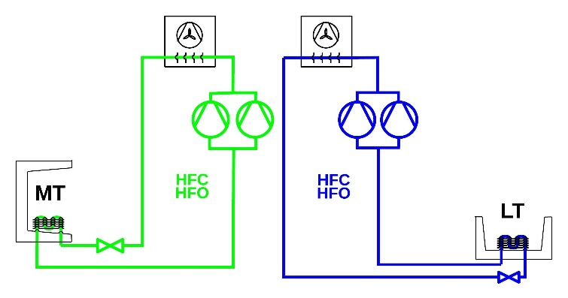 | DX-System | < 150 GWP
B | 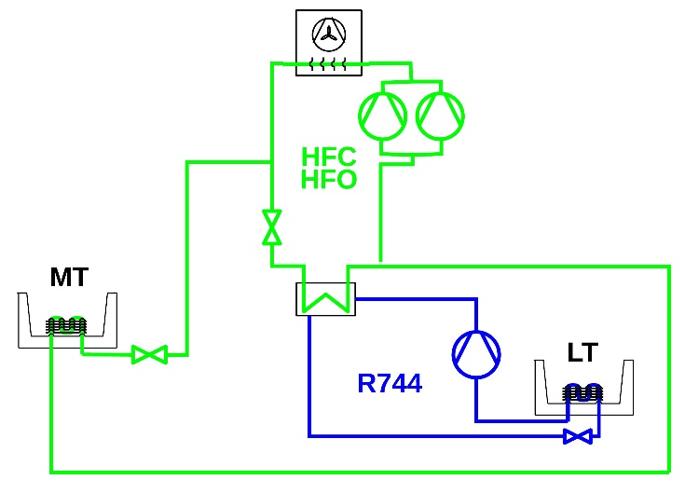 | Cascade CO₂ | < 150 GWP
C | 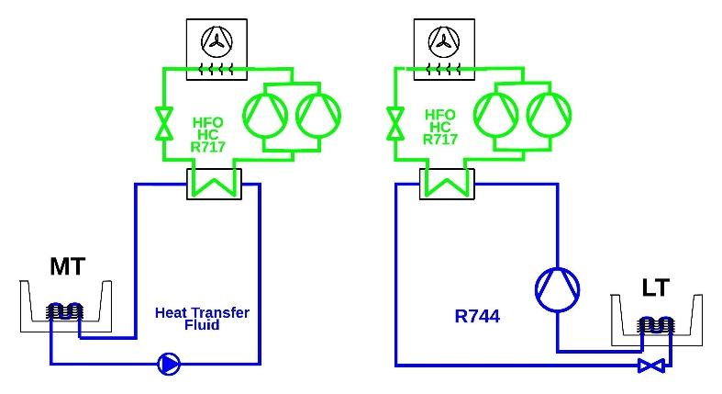 | Secondary MT refrigeration circuit and LT CO₂ cascade | < 150 GWP
D | 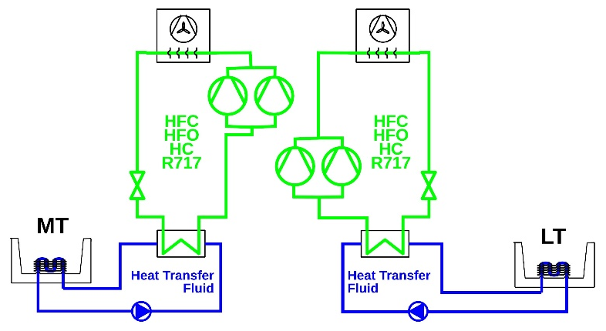 | Secondary MT/LT refrigeration circuit | < 150 GWP
E | 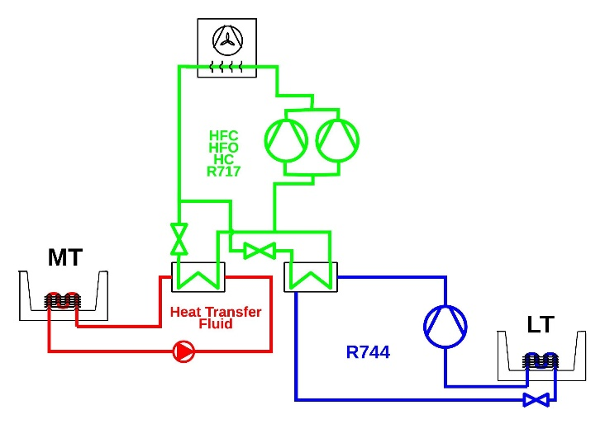 | Combined secondary MT refrigeration circuit and LT CO₂ cascade | < 1,500 GWP in primary circuit  and  < 150 GWP in other direct or indirect circuits
F | 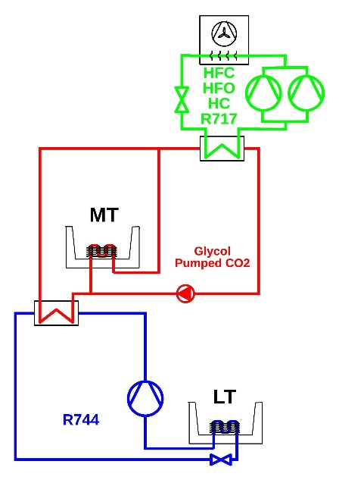 | Combined secondary MT refrigeration circuit (e.g. pumped CO₂) and LT CO₂ cascade | < 1,500 GWP in primary circuit  and  < 150 GWP in other direct or indirect circuits
G | 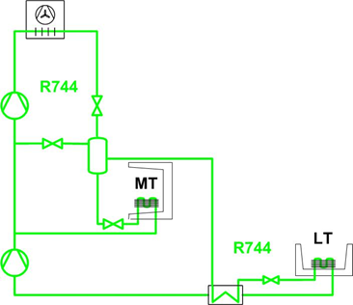 | Transcritical CO₂ | -

“Service contract for supporting F-Gas Policies – Lot 1 Supporting domestic F-gas Policies”
According to Regulation (EU) No 517/2014 ‘multipack centralised refrigeration systems’ means systems with two or more compressors operated in parallel, which are connected to one or more common condensers and to a number of cooling devices such as display cases, cabinets, freezers or to chilled store rooms.
According to Regulation (EU) No 517/2014 ‘commercial use’ means used for the storage, display or dispensing of products, for sale to end users, in retail and food services.
40kW refers to the rated capacity of a single refrigeration circuit at evaporation temperatures of -10°C for medium temperature (MT) applications and -35°C for low temperature (LT) applications at an ambient temperature of 32°C. If a refrigeration circuit can deliver both MT and LT capacity at the same time, the sum of the capacities applies. Otherwise the higher of both capacities applies. For multifunctionals only the refrigeration capacities apply and not the air conditioning or heating capacities.
According to Regulation (EU) No 517/2014 ‘primary refrigerant circuit of cascade systems’ means the primary circuit in indirect medium temperature systems where a combination of two or more separate refrigeration circuits are connected in series such that the primary circuit absorbs the condenser heat from a secondary circuit for the medium temperature.
Sample systems are provided at the end of the questionnaire.
‘Distributed systems’ refer to systems where at least two display cabinets are connected to a condensing unit that is placed inside the sales area rather than a separate machinery room. Whether or not the condensing unit is cooled indirectly via a water loop or air-cooled is irrelevant in this respect.
Attention: Other F-gas Regulation bans apply to stand-alone systems and commercial refrigerators and freezers operating with HFCs with a GWP of 150 or more are prohibited from 2022 on (see Regulation (EU) No 517/2014 Annex III (11)).
All systems shown are examples and do not provide an accurate level of detail. Icons for compressors for example imply that multiple compressors are installed.

